outer website design plan
Above sky limits.

Sebastian Fonseca
Course: Web Programming I
October 6, 2026

Outer
Outer is focused on provide the smoothest and most minimalist technological devices; with it’s unique OS that is entirely optimized for our devices. Thanks to this OS which it was decided to be called DOS (Dimensional Operative System) you can have the best ecosystem with an incredible compatibility with all our devices. Outer is essentially focused on laptops and phones whose objective is bring the best performance and life lasting devices never made.

Website

Purpose
Outer’s website purpose is meant to be made to show the public it’s products and what it makes it different than any other company.

Target Audience
Since Outer’s devices can handle high demanding tasks. This is specifically for those who perform high resources demanding tasks, which means this is meant for those who perform professionally.

Planned Pages

Home
This “Home” page will show the user what and for who is Outer meant for. In it the latest devices will be shown to the user and by choosing any option this will redirect them to the desired page.

About Us
This “About Us” page will tell the customers the history of Outer, what is its goals, vision and mission.

Phones
This “Phone” page will be several of them since Outer has a lot of phones devices that has to offer to the clients, these pages will describe each phone and what they are meant for and their differences.

Laptops
This page will also have the same function as the phone page.

Accessories
Page intended to show the accessories for Outer’s devices.

Support
This page is meant to assist the customer with any inquiries or any problems presented in their devices. This is to maintain Outer’s commitment to deliver excellent products.

Locations
It is important that Outer have in-person stores so can be more convenient for customer to acquire their desired devices faster instead of waiting for a delivery. This page is going to show what stores are around the customer area and the devices availability.

DOS (Dimensional Operative System)
This page is intended to explain customers how does Outer’s operative system was made and what makes the difference between Outer’s OS compared to any other competitor’s OS.

Logo


Colour Palette

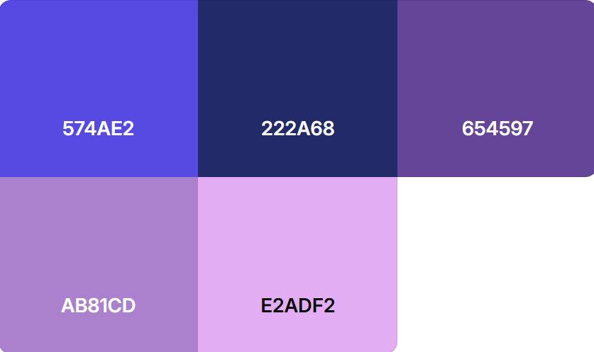

Website Banner

Mobile Layout
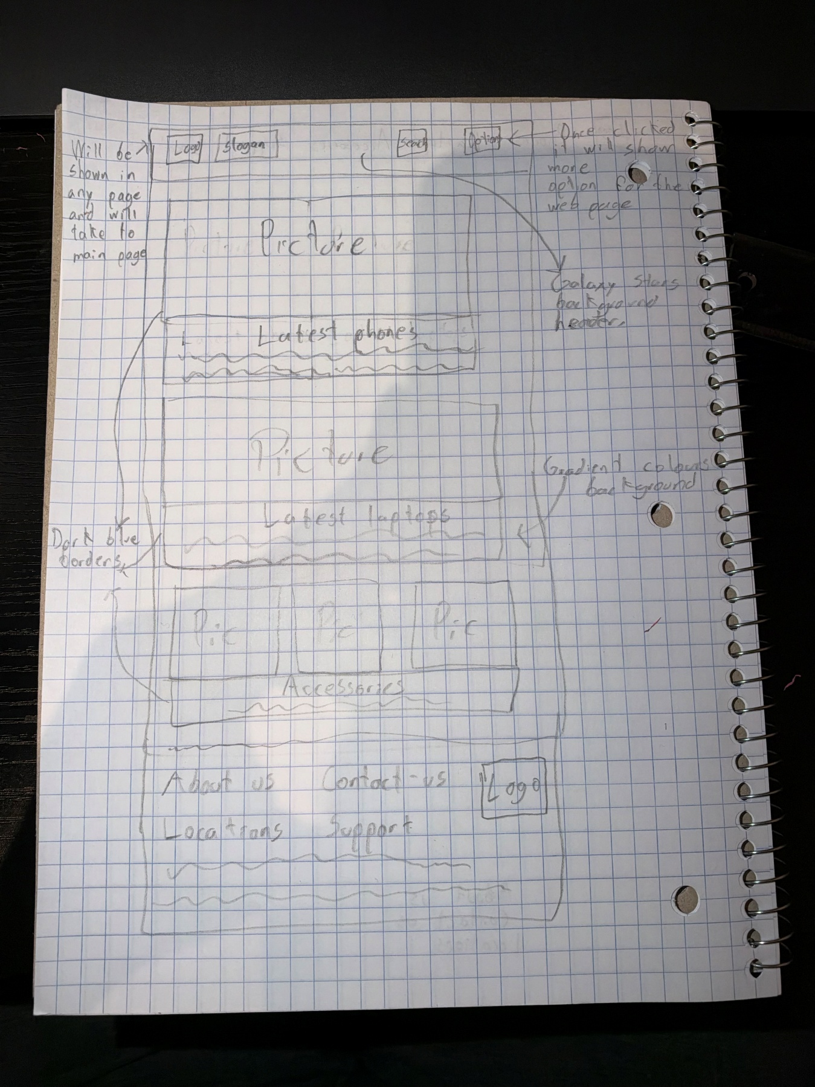

Desktop Layout


